Ideation Phase
Brainstorm & Idea Prioritization

Date | 25 November 2025
Name | Yakshagaraj A G
Project Name | Online Bookstore
Maximum Marks | 4 Marks

Brainstorm & Idea Prioritization:
Brainstorming provides a free and open environment that encourages everyone within a team to participate in the creative thinking process that leads to problem solving. Prioritizing volume over value, out-of-the-box ideas are welcome and built upon, and all participants are encouraged to collaborate, helping each other develop a rich amount of creative solutions.

Step-1: Team Gathering, Collaboration and Select the Problem Statement
The team met to understand the issues faced by readers and book buyers who prefer digital platforms.
Problems identified include: difficulty finding specific books, lack of proper filtering, and limited access to reviews before purchase.
The chosen problem statement:
“Users find it difficult to browse, search, and purchase books efficiently on traditional or poorly structured online book platforms.”

Step-2: Brainstorm, Idea Listing and Grouping
LISTING:
- Book browsing by categories
- Search and filter by genre, author, or title
- Book details page with description, price, and reviews
- User authentication
- Shopping cart
- Wishlist option
- User reviews and ratings
- Admin panel for CRUD operations
- Inventory management
- Order history for users
- Order history for users

GROUPING:
User Features:
- Register/login
- Browse books
- Search/filter
- Add to cart
- Add to wishlist
- Post reviews
Admin Features:
- Manage books (CRUD)
- Manage categories
- Manage user reviews
- Enhancement Features:
- Book recommendations
- Payment integration

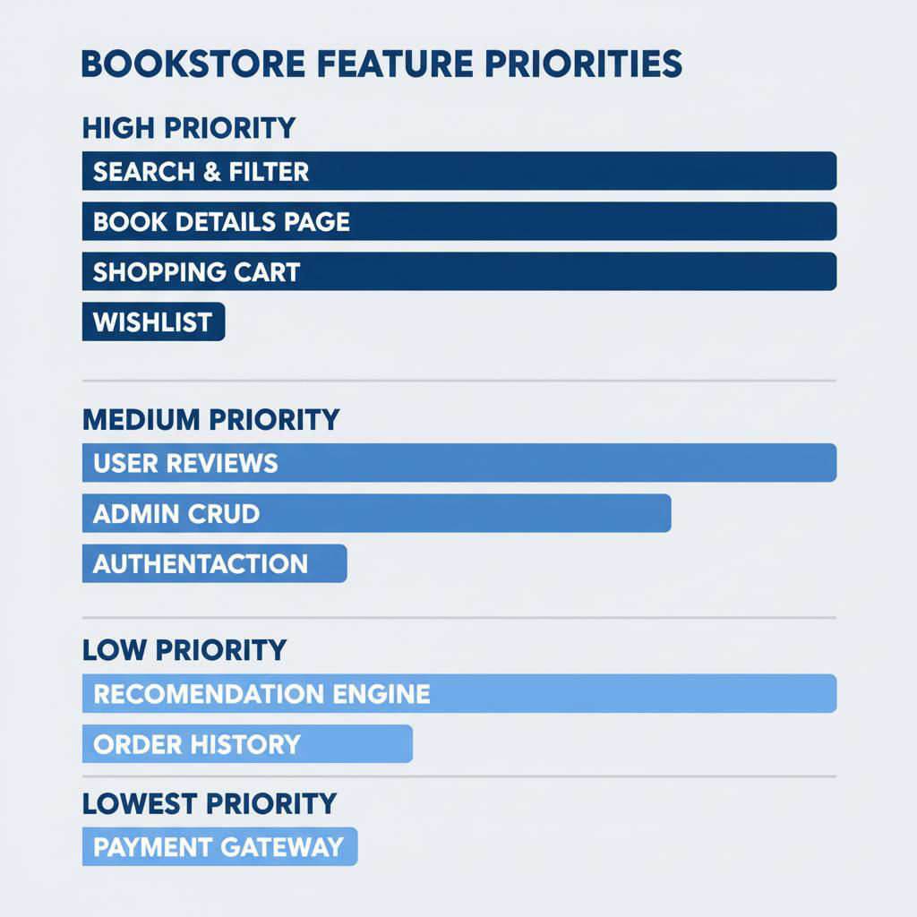
Step-3: Idea Prioritization

